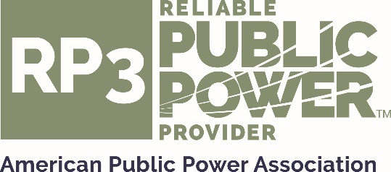

Nomination for RP₃®

Review Panel

Two seats are currently available for up to three consecutive 2-year terms. The call for nominations is for the following designated system representation:

- Medium System Representative – Association members with 5,000 to 30,000 customers. General understanding of reliability, safety, work force development, and system improvement is required.
- Large System Representative – Association members with over 30,000 customers. General understanding of reliability, safety, work force development, and system improvement is required.

E-mail this completed return this form no later than Friday March 9, 2018 to: RP3@PublicPower.org, Subject line: RP3 Review Panel Nomination – [Your Utility Name]

If you have questions regarding the nomination process, contact Christina Ospina at 202/467-2945 or email COspina@PublicPower.org.

I nominate the following person for consideration (please print or type) for the following position(s):

Medium System Representative

Large System Representative

Nominee’s Name: _____________________________________________________________

Title: ________________________________________________________________________

Utility: _______________________________________________________________________

Address: _____________________________________________________________________

City, State, Zip code: ____________________________________________________________

Phone, Fax, E-mail: _____________________________________________________________

Nomination for RP₃®

Review Panel

The nominee is recommended to serve on the RP₃ Review Panel on the following basis. Please answer questions completely, and attach additional documents if necessary:

- Number of years in public power:

- Previous job experience, including company or system name, position and number of years in each position (please attach resume if available to provide complete information):

- Nominee’s current job title and responsibilities (include information to demonstrate candidate’s knowledge of technical issues related to utility operations):

- APPA activities in which nominee has been or is involved:
- Additional qualifications (including memberships in professional or engineering organizations):

Nominator’s Signature: ___________________________________________________
Nominator’s Name (printed): _______________________________________________
Date: _________________________________________________________________
Utility: _________________________________________________________________
Title: __________________________________________________________________
Phone/Fax/Email: _______________________________________________________
Address: _______________________________________________________________
City, State, Zip code: _____________________________________________________

