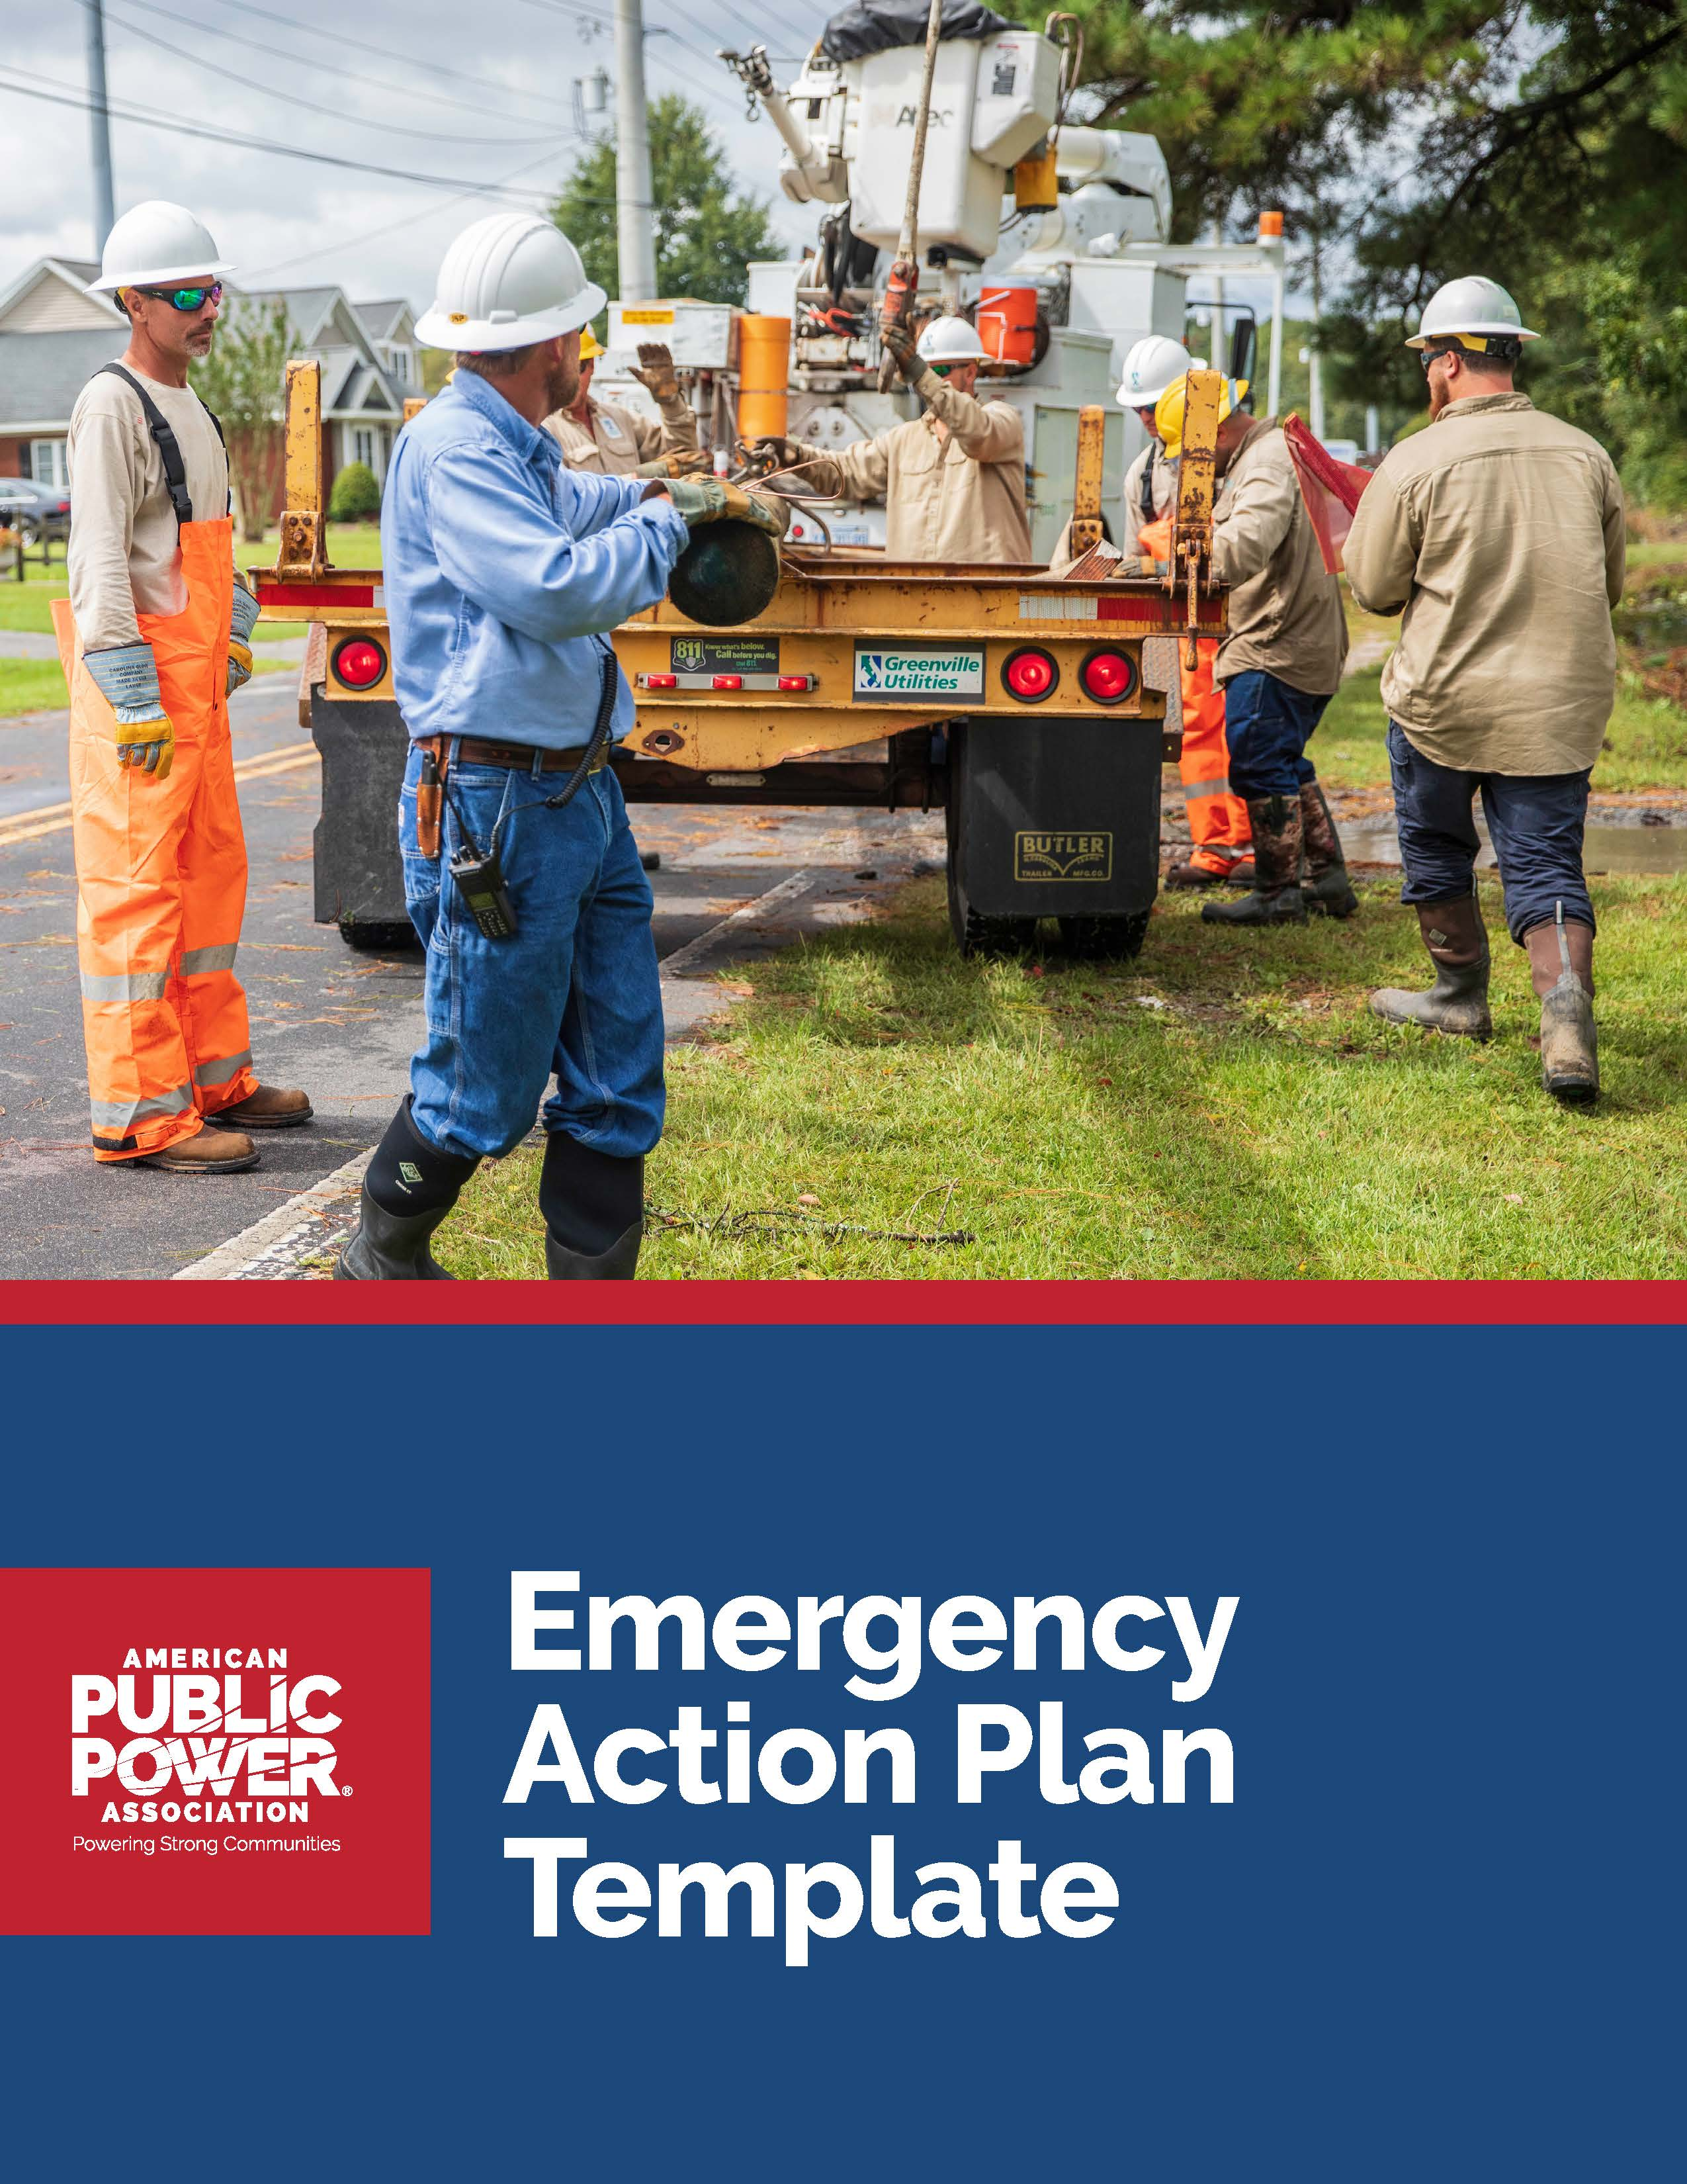

Emergency Action Plan for

[Enter Utility Name]
This Emergency Action Plan (EAP) template provides a comprehensive framework to create a plan for managing emergencies by detailing your utility’s roles, responsibilities, and procedures. Having a formal EAP ensures a structured and coordinated approach to emergency preparedness and response.
Instructions:
- Review the italicized instructions under each of the sections to understand what type of information should be entered. Once you’ve completed the section, feel free to remove the italicized language before finalizing the document and distributing internally.
- While you go through the template, please include additional information you feel is necessary. The examples in the sections provided represent a minimum best practice structure of identified areas to include in your EAP.
- Update the Table of Contents when you have completed all your edits to make sure page numbers for each section are correct. To update, click on the Table of Contents, then click on “! Update Table” and select “Update page numbers only.”

Table of Contents
Purpose 3
1. Plan Administration 4
Planning Team 4
Plan Distribution 4
Revision History 4
2. Utility/Facility Overview 4
3. Critical Infrastructure & Customers 5
4. Contact Lists 5
Internal Contacts 5
External Contacts 6
5. Mutual Aid & Vendor Agreements 6
6. Resource Inventories 6
7. Training, Drills, and Plan Maintenance 7
8. Emergency Roles & Responsibilities 7
9. Emergency Response Procedures 8
Damage Assessment 8
Triggers 8
Logistics 9
External and Internal Messaging & Engagement 9
Communication Equipment Inventory 9
Additional Restoration Locations 9
10. Appendices 10

Purpose
One of the most important steps in developing or updating an emergency plan is the formation of a planning team. The planning team consists of individuals who provide direction of the creation of your EAP and ensure alignment with other utility documents, standards, and program goals. Your team should have full cooperation of management and staff in the development of your EAP. Additional information on creating a planning team can be found on pages 8-9 of the All-Hazards Guidebook.
After forming your planning team, define what the EAP is meant to do and come up with a brief synopsis of the plan and planning framework. Identify the entities, geographic areas, and types of response for which this plan applies. State your planning assumptions, intent, and priorities.
Example purpose statement: The primary purpose of the emergency action plan is to provide processes for coordination and restoration of essential city services during and after an emergency.
Intent:
- Define lines of authority and duties in an emergency restoration operation.
- Identify actions employees are to take in support of the operation.
- Identify how outside contractors will support the operation.
- Establish actions the utility will take to prepare for an emergency with local emergency response agencies.
Typical assumptions:
- Following a significant event, most roads and streets may be impassable due to debris.
- Public works, parks and recreation, and fire departments will be available to remove debris to ensure streets and roadways are accessible for emergency response.

1. Plan Administration
Provide details about the plan owner/team, version history, and distribution list. Please note that it is a best practice to review your plan annually.

Planning Team
Name & Title | Role
John Doe, CEO/GM | Owner
Jane Smith, Emergency Manager | Subject matter expert (SME)

Plan Distribution
Your EAP may have a broad distribution and therefore utilities should consider whether to include sensitive information in the plan. As a best practice, you should refer to internal-only documents where employees can find the sensitive information. Internal recipients of your EAP include executive leadership and personnel from departments who are a part of the response. External recipients of your EAP include response partners such as police, fire, or local emergency management managers.
Recipient Name & Title | Distributed By | Date Distributed
John Doe, Emergency Manager | Jane Smith | 2024-01-01
Jane Doe, Police Department | Jane Smith | 2024-01-01

Revision History
Revisions should only be noted for significant or impactful updates, such as the purpose, utility procedures or responsibilities. Minor changes, such as updating spelling or names, do not require revision.
Change Description | Changed By | Date
Updated communication procedures | Jane Smith | 2024-02-01

2. Utility/Facility Overview
Provide basic information about the utility or facility.
Field | Details
Utility Name | Example: Utility Name
Address | Example: 123 Main St, City, ST 12345-6789
# of Customers Served | #
# of Poles on System | #
# of Transformers | #
# of Transmission Feeds In | #
# of Substations | #
# of Circuits | #
# of Meters | #
Key Personnel | Example: Key Personnel names and contact Info

3. Critical Infrastructure & Customers
As a general practice, critical infrastructure information should be protected and kept separate from administrative and program documents. Infrastructure information or other sensitive system or utility information should be available on a need-to-know or official use only basis, whereas the basic contents of an emergency plan may need to be shared with response partners such as local police, fire, or emergency management. As a general rule, specific infrastructure and system information, as well as information regarding vulnerabilities and risks, should not be included in the body of your emergency plan. EAPs may have broad distribution and therefore sensitive information should be incorporated only by reference.
Customer Name | Facility Type | Contact Info and Name | Address | Substation | Circuit
City Hospital | Healthcare | 000-555-7890 John | 123 Hospital Road | 1 | A
Police | Public Safety | 000-555-6789  Jane | 123 Police Street | 2 | B
Evacuation Center | Public Safety | 000-555-6790  Joe | 123 Safe Ave | 3 | C
Communication Provider/Hub | Comms | 000-555-7894  Joe | 123 Communication Dr | 4 | D

4. Contact Lists
Include the contact information of essential personnel and important partners in the community. Please note that this section may need to be updated and verified on a more frequent basis than your overall EAP.

Internal Contacts
Name | Role | Phone Number
Jane Smith | Operations Lead | 000-555-5678

External Contacts
Agency/Organization | Contact Person | Phone Number
Local Fire Department | Chief Brown | 000-555-9012
Local Media Contact | Joe Smith | 000-555-9011
Department of Transportation

5. Mutual Aid & Contractor Agreements
In the event that mutual aid is necessary to effectively restore power, the following contact information is utilized for contacting the appropriate agencies. Please refer to your response procedures to ensure you are contacting the correct individuals. Additionally, your utility should designate a person as the Utility Coordinator as detailed in the Mutual Aid Playbook. At a high level, Utility Coordinators serve as the primary point of contact for your utility with your Designated State Coordinator during the mutual aid process.
Organization | Type of Agreement | Contact Info
Neighboring Utility | Mutual Aid | 000-555-3456
Designated State Coordinator (as detailed in Mutual Aid Playbook) | National Public Power Mutual Aid Network | 202-467-2994
Additional Region Mutual Aid Coordinator (if applicable) | Joint Action Agency/ State Association Mutual Aid | 000-555-4567
Line Contractor | Contract | 000-555-5678

6. Resource Inventories
Equipment | Quantity | Storage Location | Contact
Generators | 3 | Warehouse A | Contact at location to verify quantities

7. Training, Drills, and Plan Maintenance
Additional information on this section is on pages 25-28 of the All-Hazards Guidebook. APPA also provides a free standalone resource, Emergency Preparedness Tabletop Exercise-in-a-Box, which provides everything you need to conduct a tabletop exercise.
Training Type | Frequency | Responsible Person
Evacuation Drill | Annually | Safety Officer

8. Emergency Roles & Responsibilities
Define a scalable chain of command structure for your utility’s emergency response. A scalable structure means you can easily expand or decrease personnel on demand dependent on the situation. Additional information can be found on pages 13-19 of the Incident Command System (ICS) Guide for Electric Utilities.
At a minimum, the following roles should be filled during emergency response: Incident Commander, Public Information Officer, Safety Officer, Liaison Officer, and Finance/Administration Section Chief. Please note that one person may be able to fill multiple roles.
Role | Responsibility | Person Assigned | Contact Info
Incident Commander | - Establishing emergency objectives and priorities  - Delegating authority for certain tasks | Utility Director or Designee (e.g., Fire Chief, Mayor, etc.) | 000-555-1234
Public Information Officer | - Gathering, verifying, and disseminating all internal information to public stakeholders | Utility Director, Mayor, or Designee | 000-555-1234
Safety Officer | - Advice on matters of health and safety | Police Chief, Fire Chief, or Other Department Head | 000-555-1234
Liaison Officer | - Communicating and maintaining externally affected organizations and ensuring utility of effort | Customer Service or Designee | 000-555-1234
Operations Chief | - Establishes objectives, plans, and activities for restoration efforts | Department Director, System Supervisor, Superintendent | 000-555-1234
Finance/Administration Section Chief | - Financial, administrative, and costs analysis including recording personnel time, administering claims, and tracking costs associated with the emergency | Finance Clerk, Billing Coordinator or Treasurer | 000-555-2345

9. Emergency Response Procedures
This section of your EAP should contain plans, procedures, and equipment that can be used in the event of a malevolent act or natural hazard that threatens your utility. The Mutual Aid Playbook provides a process for coordinating activities, information, and resources across a three-tiered national network.

Damage Assessment
Identify personnel who will perform damage assessments, when they should be performed, and the process for distributing information. Damage assessments will identify the number of poles and transformers broken, areas where tree trimming is needed, and critical infrastructure that has been impacted and will influence your utility’s response activities.
Use Appendix – Damage Assessment Form to conduct your assessments.
A critical part of damage assessment is documentation, which identify processes and information the assessment crews should be collecting. Please note the same documentation procedures should be followed throughout restoration.

Triggers
Your utility should identify who is responsible for determining whether mutual aid is needed or if you are able to complete restoration with in-house resources. The following criteria are for your consideration on whether or not to activate mutual aid: outage duration, need to restore power by a certain time, cost, crew capabilities, number of customers impacted, critical infrastructure customers impacted, type of damage, equipment damaged or needed to complete restoration.
Incident Activation Level | Triggers | Response Procedure Summary
0 | Steady state, no outages. | - No change to normal business operations
1 | Minimal outages caused by severe weather. | - Handle with in-house resources or contractors
2 | Evaluate the impacts or forecast the potential impacts to your system. If resource needs extend beyond your internal or contract resources, mutual aid should be requested through your State Coordinator.  [INSERT YOUR UTILITY’S TRIGGERS FOR ACTIVATING MUTUAL AID. OUTAGE DURATION, NEED TO RESTORE POWER BY A CERTAIN TIME, COST, CREW CAPABILITIES, NUMBER OF CUSTOMERS IMPACTED, CRITICAL INFRASTRUCTURE CUSTOMERS IMPACTED, TYPE OF DAMAGE, EQUIPMENT DAMAGED OR NEEDED TO COMPLETE RESTORATION, ETC.] | - [Insert response procedure]  - Complete the Crew Coordination Checklist for your utility’s needs  - Contact your Designated State Coordinator  - Follow the steps outlined below

Logistics
Example:
- General

- Field crews will report to TBD location to check-in, receive a safety briefing, and be assigned a Utility Liaison. Supervisors will make sure employees and crews are equipped with the proper PPE and work gear.
- Radios and batteries will be made available to all Utility Liaisons and emergency workers as needed.
- Diesel, gas, ice, drinks and emergency material packs shall be available at TBD location(s).
- Generally, breakfast (5:00 am-6:00 am) will be served at a utility TBD location(s).
- Lunch (12:00 pm-1:00 pm) and dinner (7:30 pm-8:30 pm) shall be served at a utility TBD location(s).
- The rest station area(s) are TBD location(s).
- An area will be available at TBD location for utility field crews to rest at night, if needed.

- Phone Team
Information collected by the Phone Team shall be entered into a database to assist the Incident Commander in determining work tasks.
- Warehouse Materials Delivery Team
Warehouse personnel shall be responsible for preparing and delivery emergency materials to staging locations.
- Miscellaneous
Utility employees shall be utilized as Liaisons.

External and Internal Messaging & Engagement
Communication during an incident is critical to relay information to employees, government agencies, the public, the media, and others about potential risks to health, infrastructure, and the environment. This information should be presented in a timely and accurate manner to enhance understanding of an incident, build trust and credibility, encourage constructive dialogue, and provide guidance on appropriate protective actions following the incident.
You can also reference the Public Power Storm Communications Guide for tips and best practices to communicate effectively before, during, and after a storm.
Time | Contact | Communication Method | Description
I + 0 Minutes: First Impacts (I) Observed | General Manager | Cell or Microsoft Teams | Inform utility leadership of the situation
I + 1 Hour | Designated State Coordinator | Cell | Provide situation awareness

Communication Equipment Inventory
Equipment Type | Quantity | Location
Two-way Radios | 10 | Main Office
Mobile Phones
Satellite Phones
Satellite Internet

Additional Restoration Locations
Depending on the severity of the event, facilities that you planned on using may be inaccessible. Your utility should identify other locations that could potentially be used to either run your emergency operations or as staging areas.
Location Name | Purpose | Address
City High School | Debris staging area | 123 High School Drive

10. Appendices
Appendix Type | Description
Incident Command System Structure (Fillable) | Complete the form on p. 13 with the personnel in charge of the event
Damage Assessment Form | Complete the form on p. 14 when conducting damage assessment
Vendor Agreement(s) | As a best practice, each year, seek quotes from at least 3 vendors
Forms | Emergency response forms such as incident logs and cost tracking
Checklists | Bomb threat checklist, contamination checklist, etc.
Sample Press Releases | Templates for public communication during emergencies
Regulatory References | Relevant laws and regulations
Standard Operating Procedures (SOPs) | SOPs for emergency scenarios

Safety Officer:
Incident Commander:

Public Information Officer:

Liaison Officer:

Finance/Admin Chief:
Planning Section Chief:
Operations Section Chief:
Logistics Section Chief:

Damage Assessment Form

Circle items as applicable
Date: Time: am pm FEEDER No. Recorded By: Crew at Site:
Line or TT
Address/Location Customer Count on Tap, Feeder, or Transformer
Comments about damage upon arrival:

POLE | Number |  | Primary Down |  |  | Front | Rear
 | TAP No. and Size |  | /  Light Pole Down |  |  | amps  Front | Rear
WIRE Service |  | Down | OH | UG | Length ft |  | Size #
Secondary |  | Down | OH | UG | Length ft |  | Size #
Primary |  | Down | OH | UG | Length ft |  | Size #
TRANSFORMER Leaking Oil Needs to be picked up

No. Size KVA Voltage V

REPAIR / REPLACE

CROSSARM CUTOUT INSULATOR JUMPER POTHEAD

ELECTRIC METER No. Was pulled Reading GENERATOR on site Service was cut at house, wire rolled up to the pole

amp Fuse size was replaced on Pole No. Customer Amount
TREE to be cut to be moved Fill In Ruts

PICKUP Brush Trash Tree located by

FENCE / BLDG damaged by storm damaged by work crews
Height / App Length ft / ft Wood Chain Link Other
Describe BLDG

Additional Comments:

