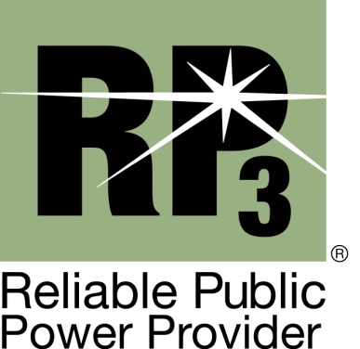

Nomination for RP₃®

Review Panel

The call for nominations is for the following designated system representation only: (3 seats are currently available for up to three consecutive 2 year terms.)

- Small System Representative – APPA member with less than 5,000 customers. General understanding of reliability, safety, workforce development, and system improvement is required.

- Joint Action Agency/State Association Representative – APPA member from a Joint Action Agency or State Association with a general understanding of reliability, safety, workforce development, and system improvement is required.

- System Improvement Representative – APPA member with expertise in the system improvement and maintenance aspect of utility operations is required.

E-mail this completed form no later than Tuesday, July 5th, 2022 to: RP3@PublicPower.org, Subject line: RP3 Review Panel Nomination – [Your Utility Name]

If you have questions regarding the nomination process, contact the RP3 team at RP3@PublicPower.org.

Nomination for RP₃®

Review Panel

I nominate the following person for consideration (please print or type):

Nominee’s Name: _________________________________________________________

Title: __________________________________________________

Utility: __________________________________________________________

Address: ___________________________________________________________

City, State, Zip code: __________________________________________________

Phone, Fax, E-mail: ___________________________________________________

Please continue to the next page.

Nomination for RP₃®

Review Panel

The nominee is recommended to serve on the RP₃ Review Panel on the following basis:

- Number of years in public power:

- Previous job experience, including company or system name, position and number of years in each position (please attach resume if available to provide complete information):

- Nominee’s current job title and responsibilities (include information to demonstrate candidate’s knowledge of technical issues related to utility operations):

- APPA activities in which nominee has been or is involved:
- Additional qualifications (including memberships in professional or engineering organizations):

Nominator’s Signature: ______________________________________ Date: ____________

Nominator’s Name (printed): _______________________________________

Utility: __________________________________________________

Title: _______________________________________________________

Phone/Fax/Email: ___________________

Address: ____________________________________________________

City, State, Zip code: ___________________________________________

