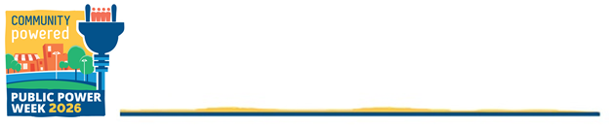
SAMPLE PUBLIC POWER WEEK SOCIAL MEDIA
MESSAGES AND GRAPHICS
Public Power Week 2026: October 4–10
Theme: “Your Community. Your Utility. Your Power.”
Post these sample messages on Facebook, LinkedIn, Instagram, and X during Public Power Week. Customize bracketed placeholders with local details, events, programs, and links. Use #PublicPowerWeek and #PublicPower, and tag community partners when relevant.
- Suggested customization: Add your utility name, community name, website, local programs, events, and customer-service information.
- Instagram note: Add relevant local hashtags and use the location tag when appropriate.
- Watch or download the 2026 Public Power Week video

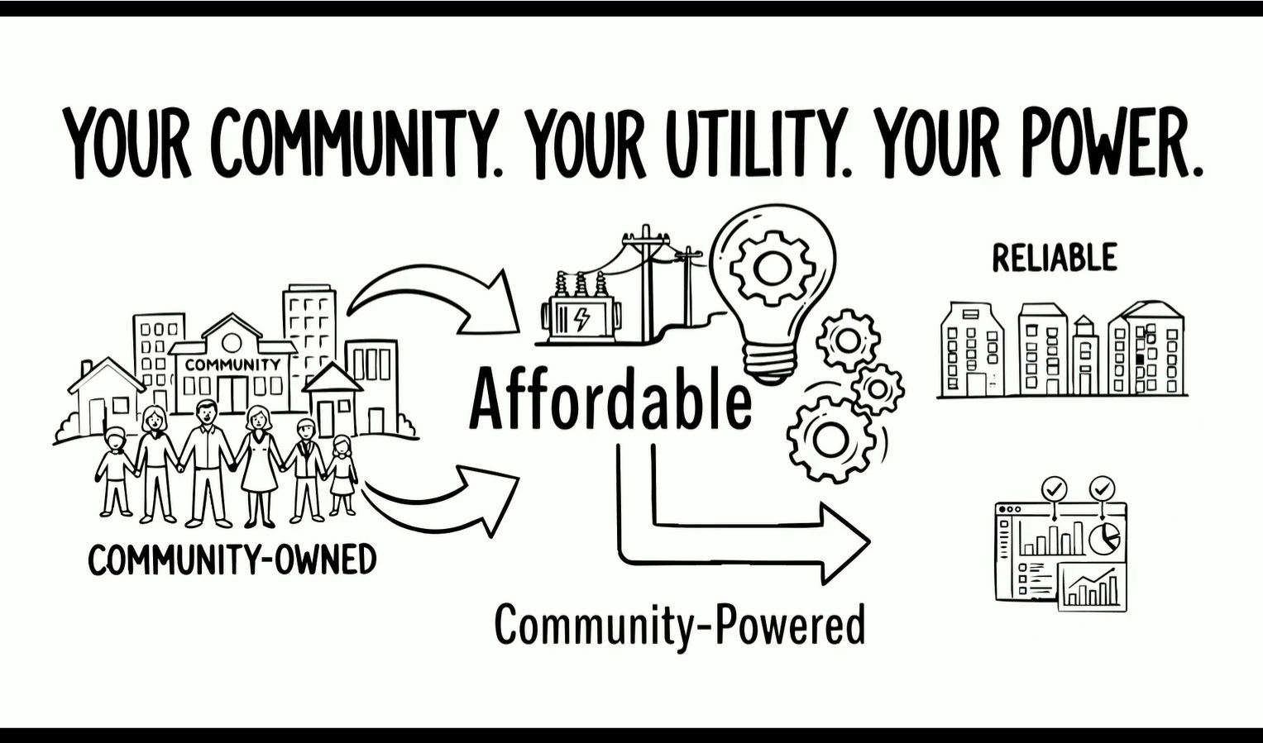

FACEBOOK / LINKEDIN / INSTAGRAM / X

COMMUNITY OWNERSHIP AND LOCAL VOICE

Message #1
Today kicks off #PublicPowerWeek! From Oct. 4–10, we’re celebrating the people who make our community strong and the utility that serves them. At [UTILITY NAME], local priorities guide how we serve [COMMUNITY NAME], because this is your community, your utility, and your power. Learn more: [YOUR WEBSITE URL] #PublicPower
Message #2
Public power starts here at home. Because [UTILITY NAME] is municipally owned, the people of [COMMUNITY NAME] have a voice in decisions about our energy future. This #PublicPowerWeek, tell us what matters most to you: [ENGAGEMENT QUESTION OR LINK] #PublicPower
Optional local detail prompts: customer advisory groups, public meetings, locally approved projects, or energy-planning priorities.

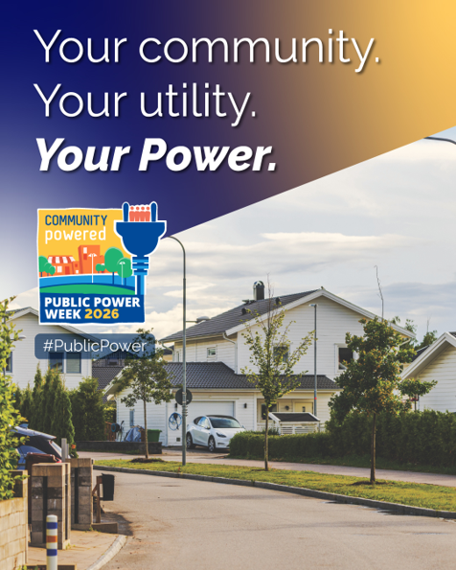

RELIABLE SERVICE AND LOCAL RESPONSE
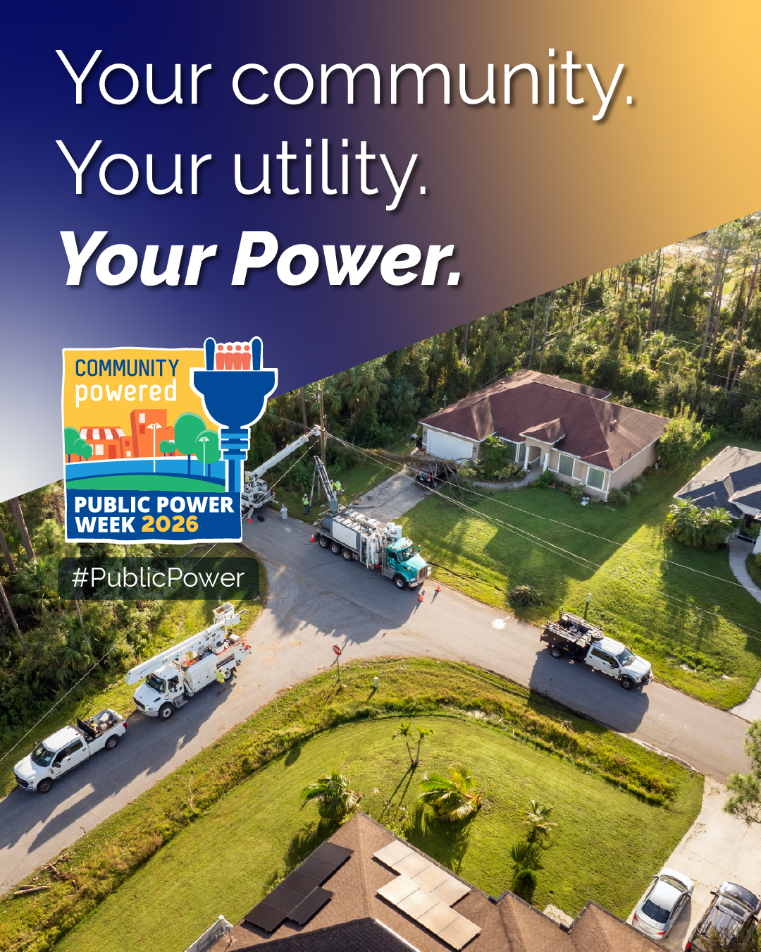
Message #3
Reliable service takes planning, preparation, and a team committed to the community it serves. During #PublicPowerWeek, we recognize the employees of [UTILITY NAME] who work year-round to keep [COMMUNITY NAME] powered and respond when our neighbors need us most. #PublicPower
Message #4
When service is disrupted, local crews and community-focused decision-making help [UTILITY NAME] respond with [INSERT LOCAL RESPONSE OR RELIABILITY DETAIL]. Our team lives and works in the community we serve. Your community. Your utility. Your power. #PublicPowerWeek #PublicPower
Optional local detail prompts: reliability investments, vegetation management, storm preparation, mutual aid, or restoration milestones.

COMMUNITY SERVICE AND VOLUNTEERISM
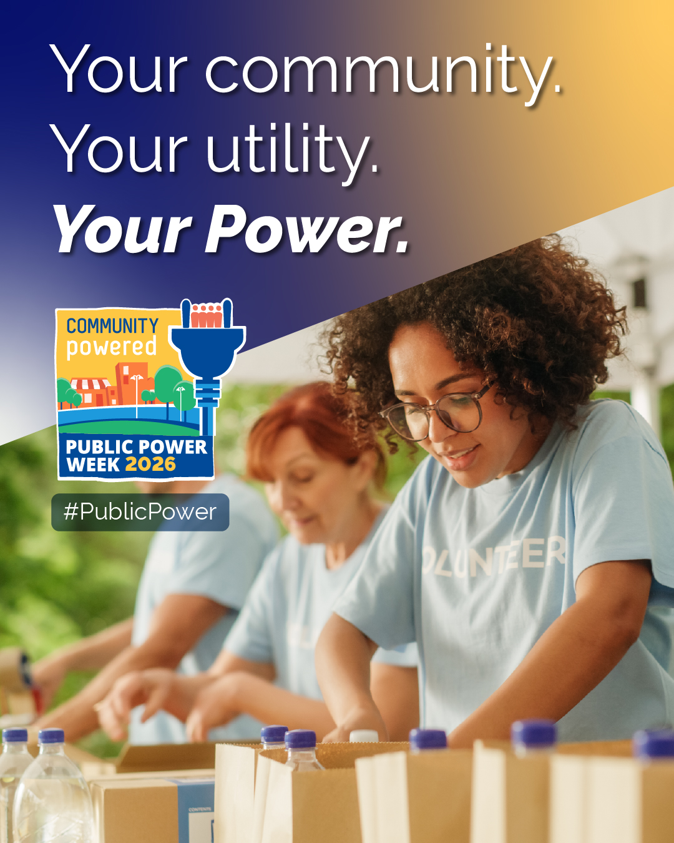
Message #5
Being community-powered means doing more than delivering electricity. It means showing up, lending a hand, and investing in the place we call home. This year, [UTILITY NAME] employees supported [LOCAL PROGRAM, NONPROFIT, OR VOLUNTEER EFFORT]. #PublicPowerWeek #PublicPower
Message #6
Our connection to [COMMUNITY NAME] goes beyond poles and wires. Through [COMMUNITY PROGRAM OR PARTNERSHIP], [UTILITY NAME] is working alongside local organizations to help our community thrive. Learn more: [YOUR WEBSITE URL] #PublicPowerWeek #PublicPower
Optional local detail prompts: employee volunteerism, school partnerships, charitable drives, energy-assistance programs, or civic events.

CUSTOMER CONNECTION AND COMMUNITY PARTICIPATION
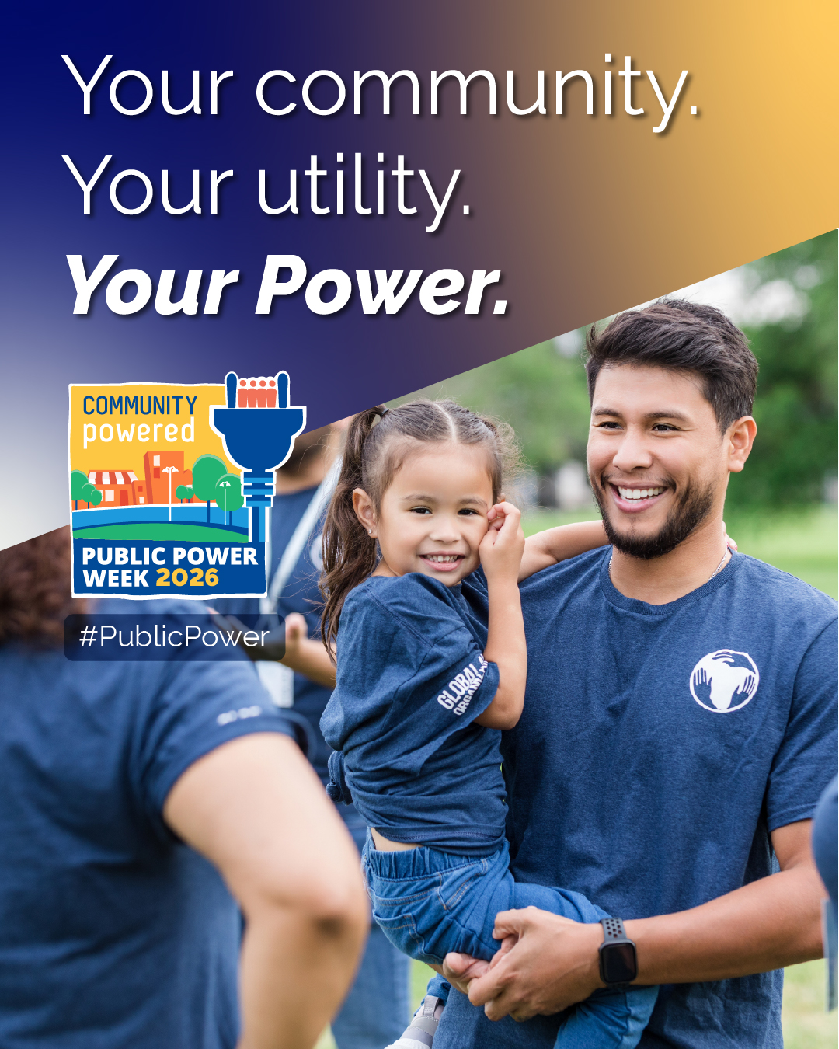
Message #7
Public power belongs to the community. That means listening to customers, welcoming participation, and building an energy future that reflects local needs. Join us for [EVENT] on [DATE/TIME] at [LOCATION] and help celebrate #PublicPowerWeek. [EVENT LINK] #PublicPower
Message #8
Your ideas help power our progress. During #PublicPowerWeek and throughout the year, [UTILITY NAME] invites customers to connect with us through [MEETING, SURVEY, OPEN HOUSE, OR CUSTOMER PROGRAM]. Share your perspective: [YOUR WEBSITE URL] #PublicPower
Optional local detail prompts: open houses, community events, surveys, board or council meetings, customer programs, or public tours.

A COMMUNITY-POWERED FUTURE
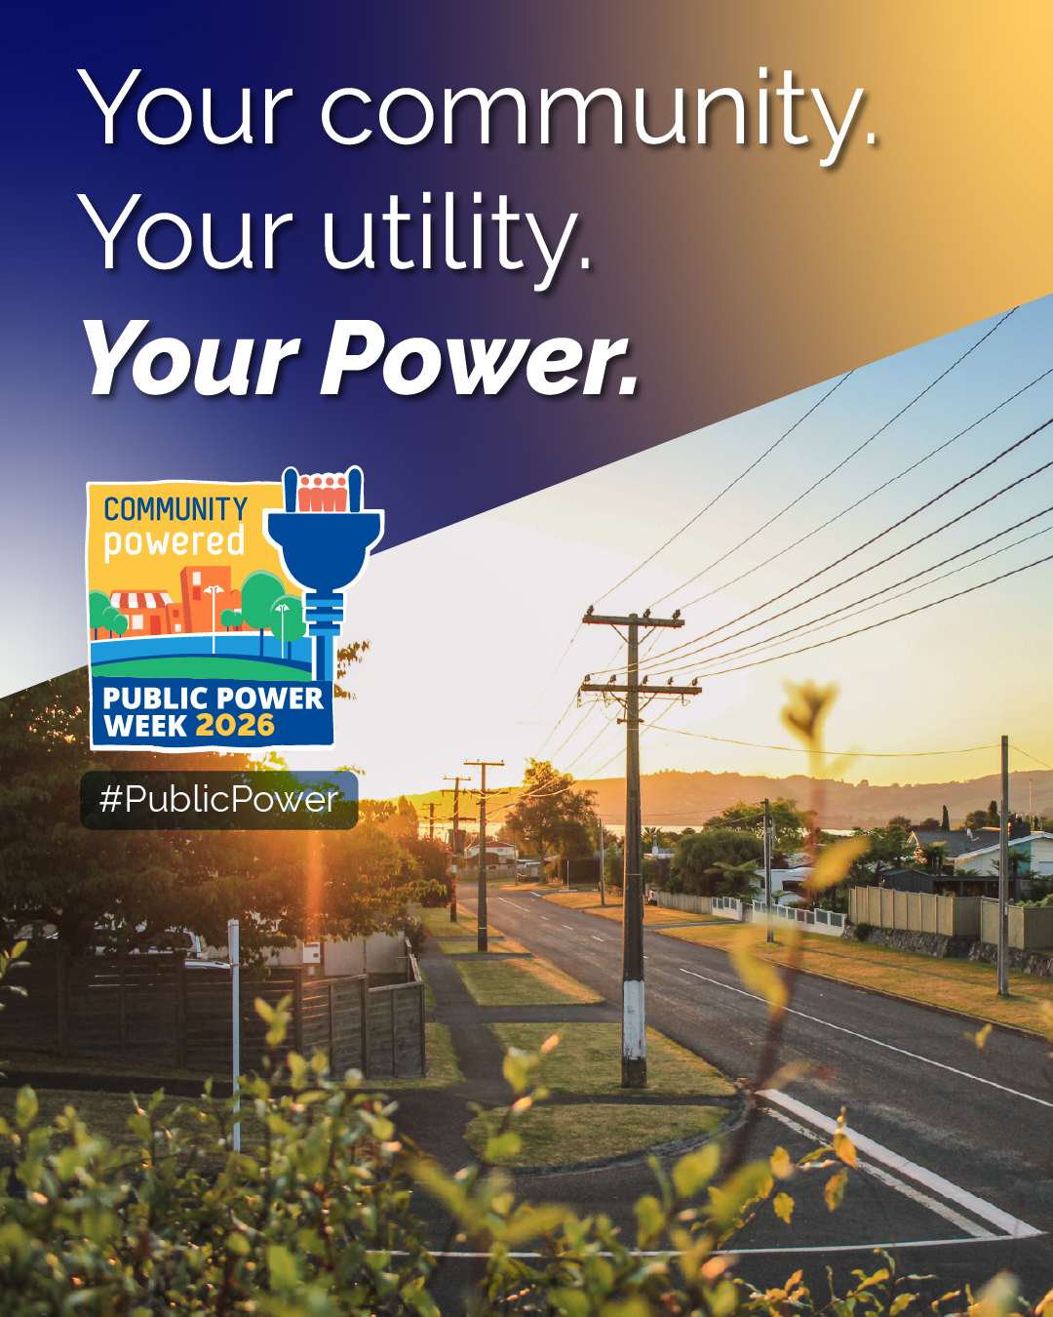
Message #9
For [NUMBER] years, [UTILITY NAME] has powered the homes, businesses, schools, and public spaces that make [COMMUNITY NAME] home. Community ownership keeps our focus where it belongs: on the customers and community we serve. #PublicPowerWeek #PublicPower
Message #10
Your community. Your utility. Your power. This #PublicPowerWeek, we celebrate the local choices, public service, and shared commitment that keep [COMMUNITY NAME] moving forward. Discover what public power means for you: [YOUR WEBSITE URL] #PublicPower
Optional local detail prompts: utility history, infrastructure improvements, economic development, customer programs, or plans for future growth.

