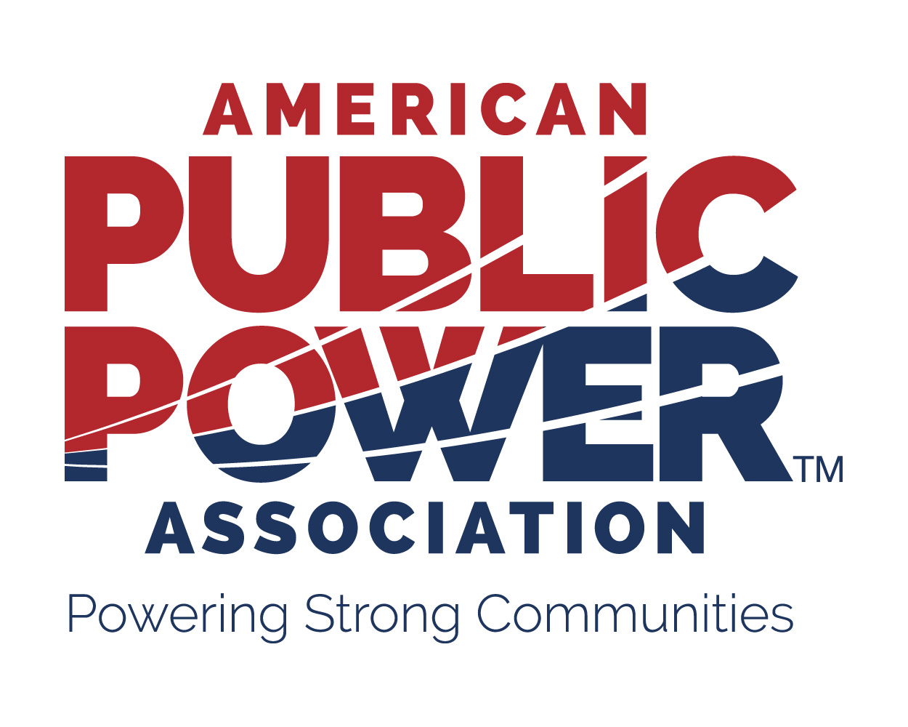

Changes and Additions to the Legislative & Resolutions Committee Representative

APPA's Legislative and Resolutions (L&R) Committee formulates policy positions on issues affecting public power utilities and submits to APPA members for their consideration resolutions encompassing these recommendations. Each regular member of APPA is allowed one voting member on this committee.

The committee meets annually at the APPA Legislative Rally held each winter in Washington, D.C. Please make any changes prior to this meeting (please see the events calendar on the website) and send the form back to:

Clay Bryan

cbryan@publicpower.org

If you will be sending a different voting representative to the L&R Committee meeting or you do not currently have a representative on the committee, please fill out his or her contact information on the form below:

Name

Title

Utility

Address

Phone Email

Is this person:
Replacing your current L&R Committee member

OR

Representing your organization for the 2020 Legislative Rally ONLY*.

* Please list the main delegate for your organization below:

Name

Thank you for participating in the L&R Committee.

